CLOUD COMPUTING


SUBMITTED TO
ENGR. SHOAIB

SUBMITTED BY
HAMNA MAHMOOD
2023-BSE-025
BSE V-A

Lab 6
Lab Title
Linux Users, Groups, Permissions, Pipes, and Bash Scripting

Task 1

Switch to root with su – and back to a normal user
Set a root password
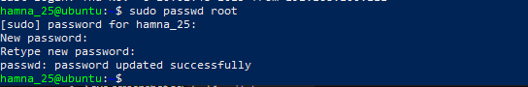
Entered a temporary root password for this lab.
Switch to the root user and verify:
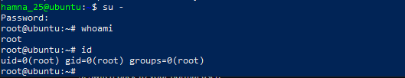

Switch back to the normal user and verify:

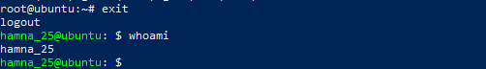

Task 2

Create user tom and verify in passwd/group/shadow
Create a new user tom (interactive command that sets a password and creates a home directory):
Password:tom123
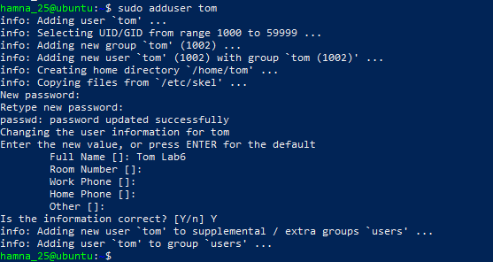
Verify user tom in the /etc/passwd file

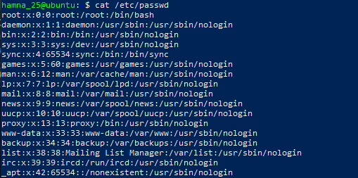
.
Verify user tom in the /etc/group file:

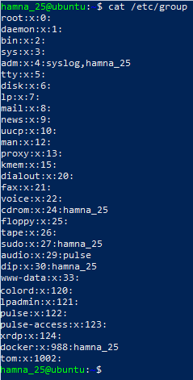

Verify user tom in the /etc/shadow file:
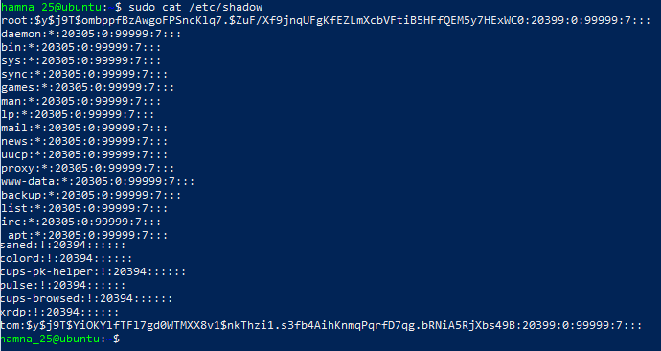

Task 3

Create groups; change tom’s primary and secondary groups
Create the required groups and verify:
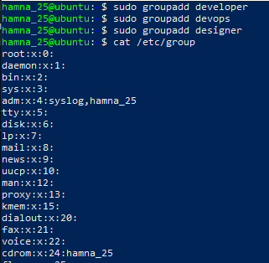

Change tom’s primary group to designer and verify:
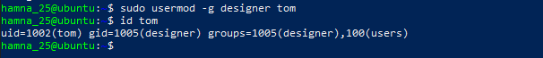

Add secondary groups developer and devops to tom and verify:
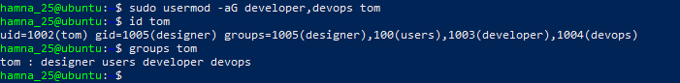

Replace secondary groups so only tom (user’s own group) remains and verify:
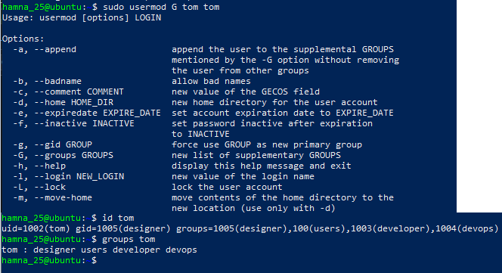

Task 4

Create/Delete Users (Jerry, Scooby) and Groups (jolly, anime)

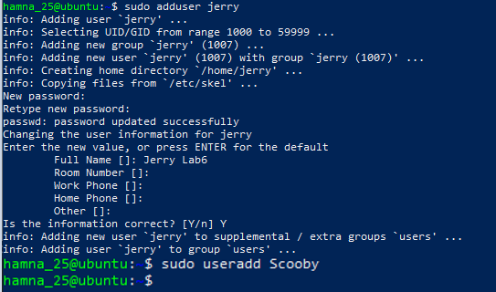
Attempt to log in as Scooby before setting a password (expected failure):

Set a password for Scooby:
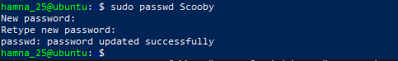

Log in again as Scooby (observe missing home directory warning):

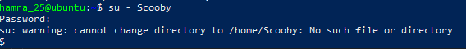

Verify Scooby’s home directory and /etc/passwd entry
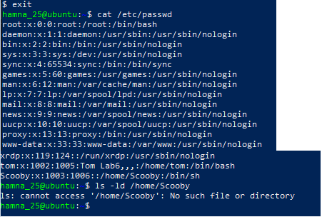

Manually create Scooby’s home directory and set ownership/permissions:
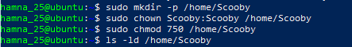

Log in as Scooby again to confirm correct home directory access:
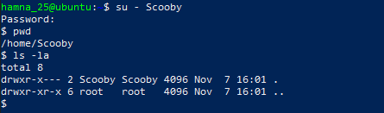

Verify users in /etc/passwd and check Scooby’s shell:
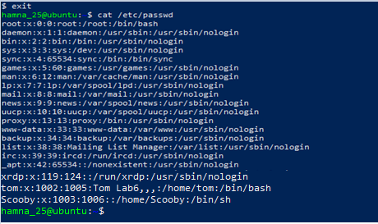

Change Scooby’s shell from /bin/sh to /bin/bash and verify:
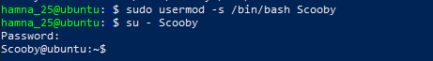

Create groups jolly and anime:
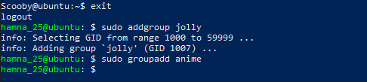

Verify groups in /etc/group:
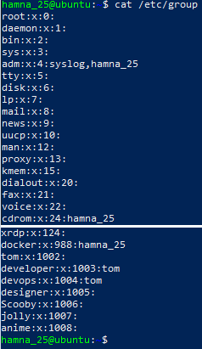

Delete the groups and users:
task4_delete_groups

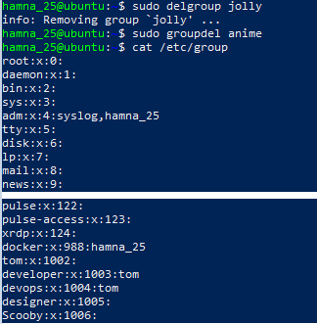
task4_delete_users
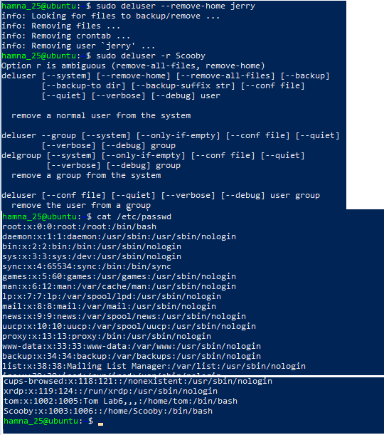

Task 5

Create User “Student”; Create Files; Set Owner/Group; Identify File Types
Create a new user Student:
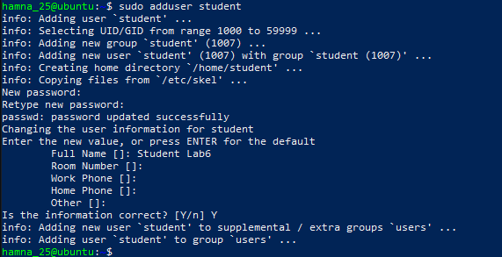

Switch to Student and create files and directories:
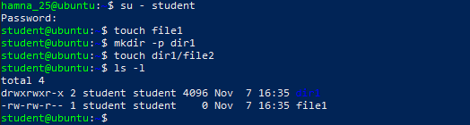

Change the owner of file1 to tom and verify:
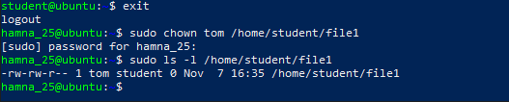

Change the group of file1 to devops and verify:

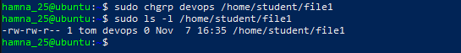

Identify files, directories, and special files:
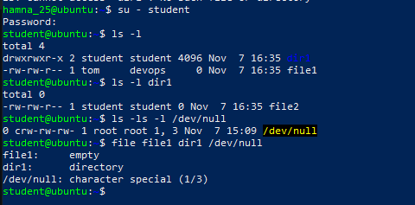

Exit from Student account:
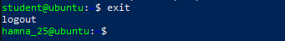

Task 6:

Change Permissions Using Symbolic Mode
Ensure the Student user and target file exist:
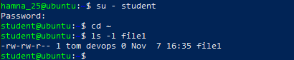

Remove all permissions from file1:
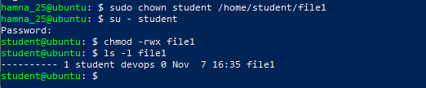

Add read permission to all users:
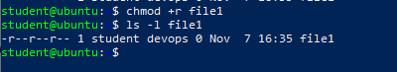
Add execute permission to the user (owner):
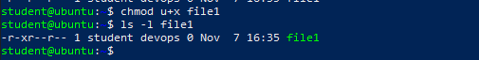

Add write permission to both user and group:

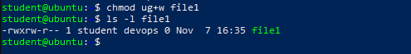

Remove all permissions explicitly from user, group, and others:
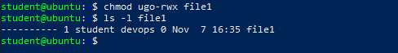

Task 7

Change Permissions Using “Set” Symbolic Form (u= g= o=)
Ensure you are logged in as Student and confirm the file exists:
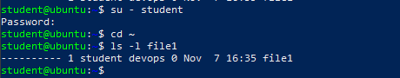

Set all permissions (read, write, execute) for user, group, and others:

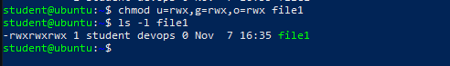

Remove execute permission from group and others:
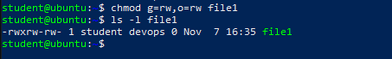

Remove all permissions from user, group, and others:
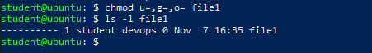

Task 8

Change Permissions Using Numeric (Octal) Mode
Ensure you are logged in as Student and the file exists:

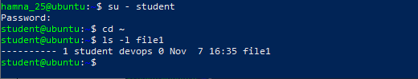

Set permissions to 777 (rwx for user, group, and others):
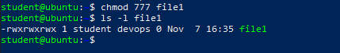

Set permissions to 700 (rwx for user only):
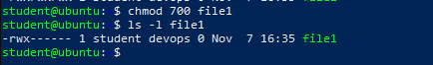

Set permissions to 744 (rwx for user, read for group and others):
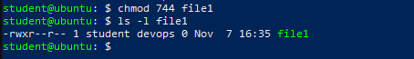

Set permissions to 640 (rw for user, r for group, none for others):
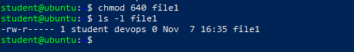

Set permissions to 664 (rw for user and group, read for others):
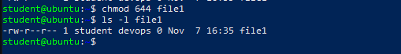

Set permissions to 775 (rwx for user and group, read/execute for others):
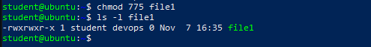

Set permissions to 750 (rwx for user, read/execute for group, none for others):
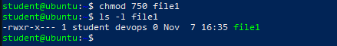

Task 9

Practice Pipes, Pagers, Grep, and Redirects with /var/log/syslog
View /var/log/syslog using less (with pipe):
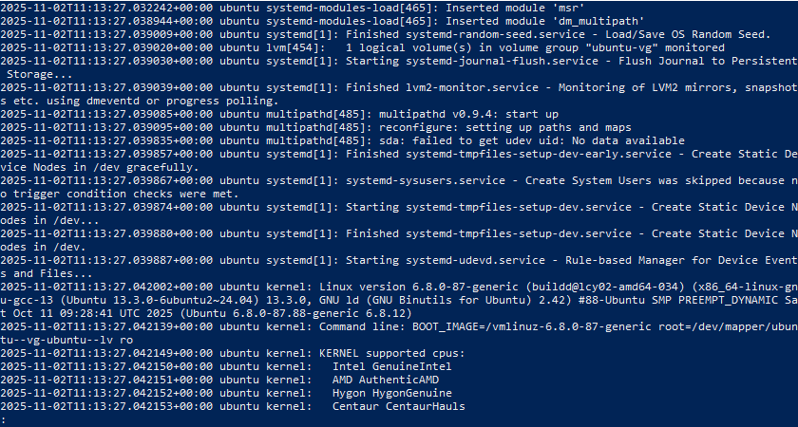

View /var/log/syslog using more (with pipe):
sudo cat /var/log/syslog | more

Search for log entries containing “fail” or “error”:
sudo grep -E 'fail|error' /var/log/syslog | head
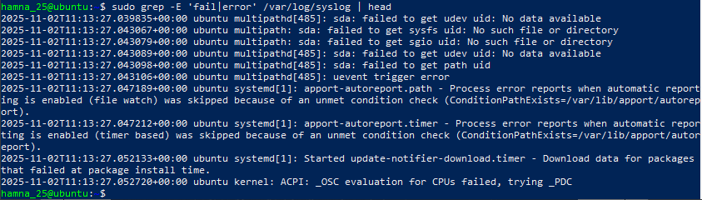

Redirect search results to a new file (overwrite mode):

Append additional search results to the same file:
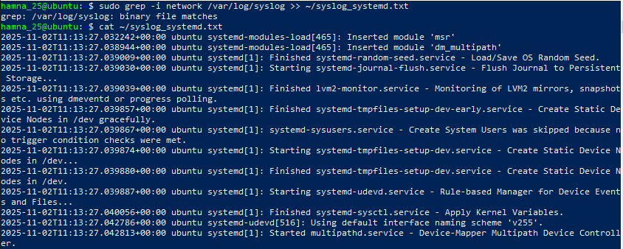

(Alternative) Use journalctl to explore logs:
sudo journalctl | less

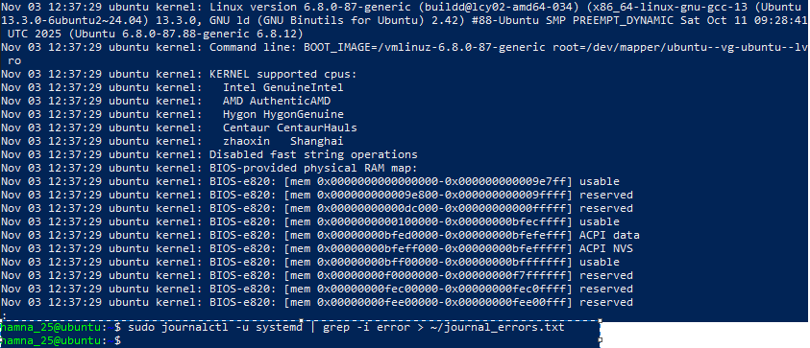
Viewed and filtered logs directly from systemd journal as an alternative to /var/log/syslog.

Task 10

Bash Script: setup.sh (Variables, Command Substitution, File/Dir Checks, Permissions)

Add Bash Shebang
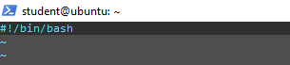

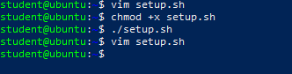

Define and Display a Variable

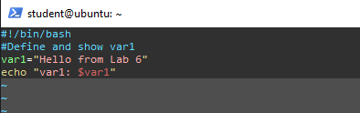

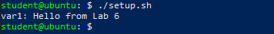

Command Substitution: Save and Display ls -l

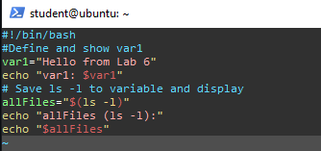
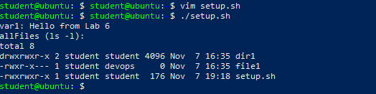

Directory Check and Creation
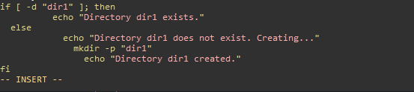
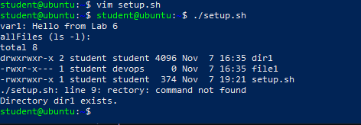

File Check and Creation

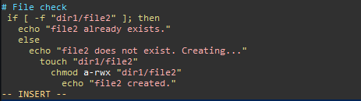
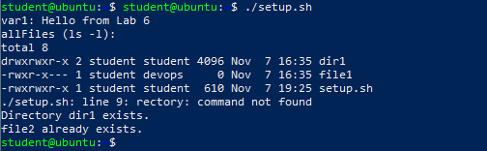

Permission Check and Adjustment

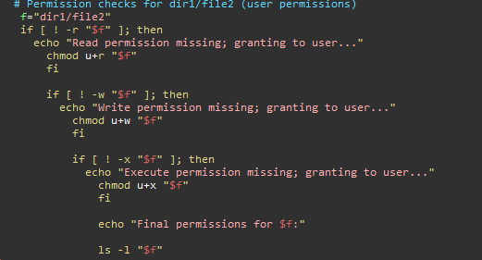

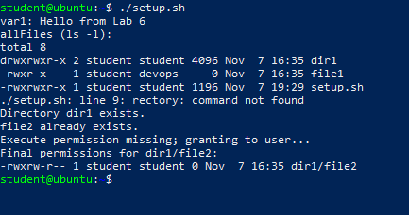

Task 11

Script setup.sh – Argument Comparisons and String Checks

Shebang, Variable Setup

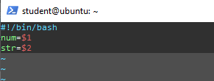
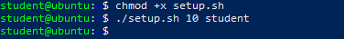

Numeric Equal ( -eq )

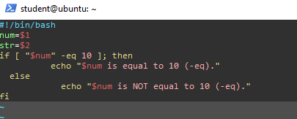

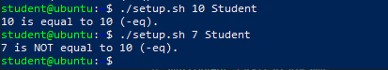

Numeric Not Equal ( -ne )

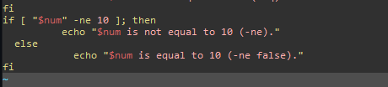

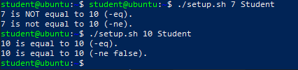

Greater Than ( -gt )

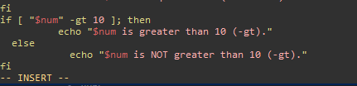
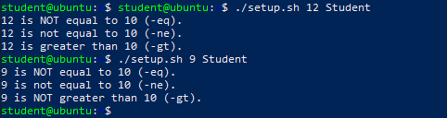

Less Than ( -lt )

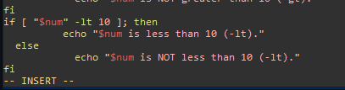
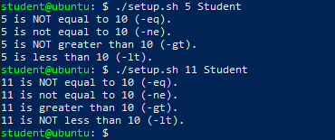

Greater Than or Equal ( -ge )

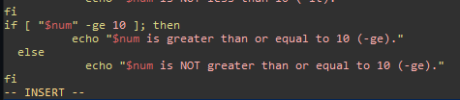
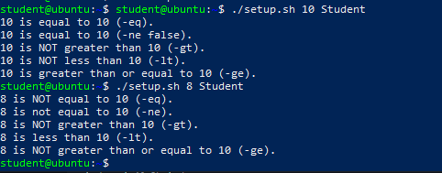

Less Than or Equal ( -le )

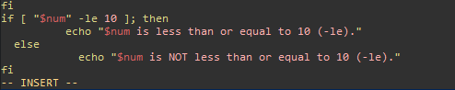
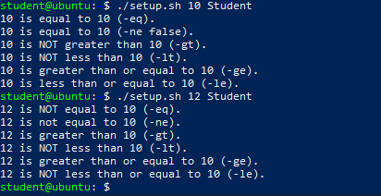

String Equality ( = )

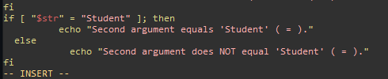
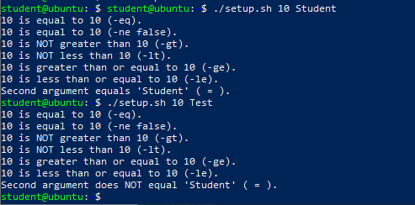

String Inequality ( != )

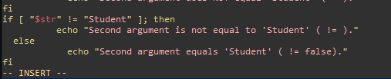
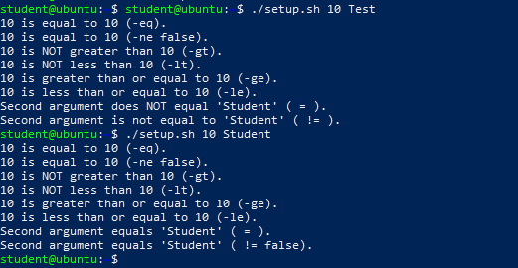

String Zero-Length ( -z )

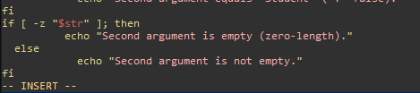
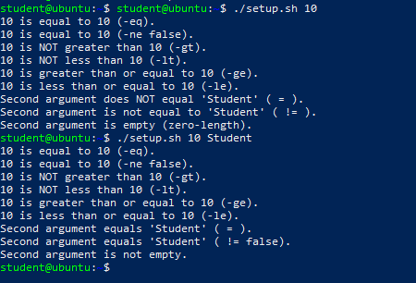

Task 12

Script setup.sh – Print All Arguments with a For Loop
Goal:
Shebang and Comment

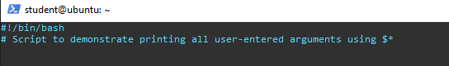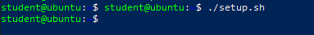

Append the For Loop Using $*
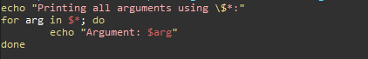
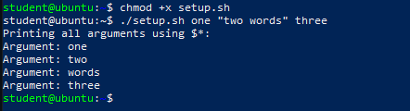

Task 13:

Script setup.sh – While Loop Summation and Functions

Shebang Line
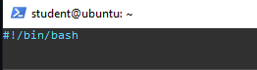
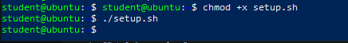

Interactive While Loop Summation
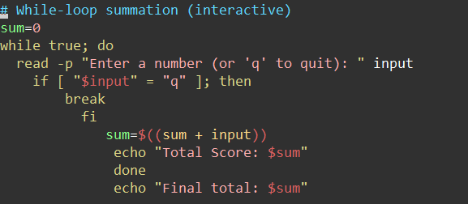
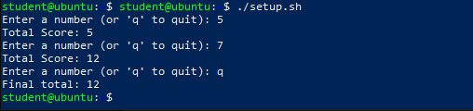

Function sum_two() (Interactive Loop Inside a Function)
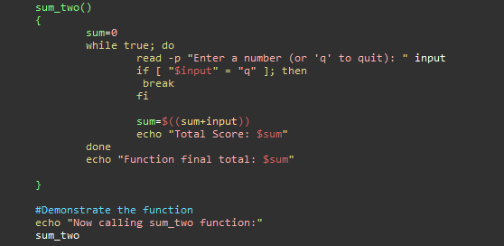
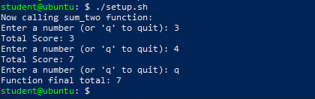

Function sum_args() (Two Arguments Summation)
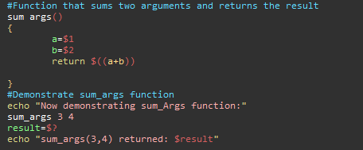
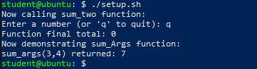

Task 14

Codespaces GUI: Fork Repo, Start GUI, Connect via VNC, Stop GUI
- Fork the repository to your GitHub account
  - Open the repo URL in your browser.
https://github.com/WaqasSaleem97/UbuntuMachine
  - Click Fork (top-right) and fork to your account.
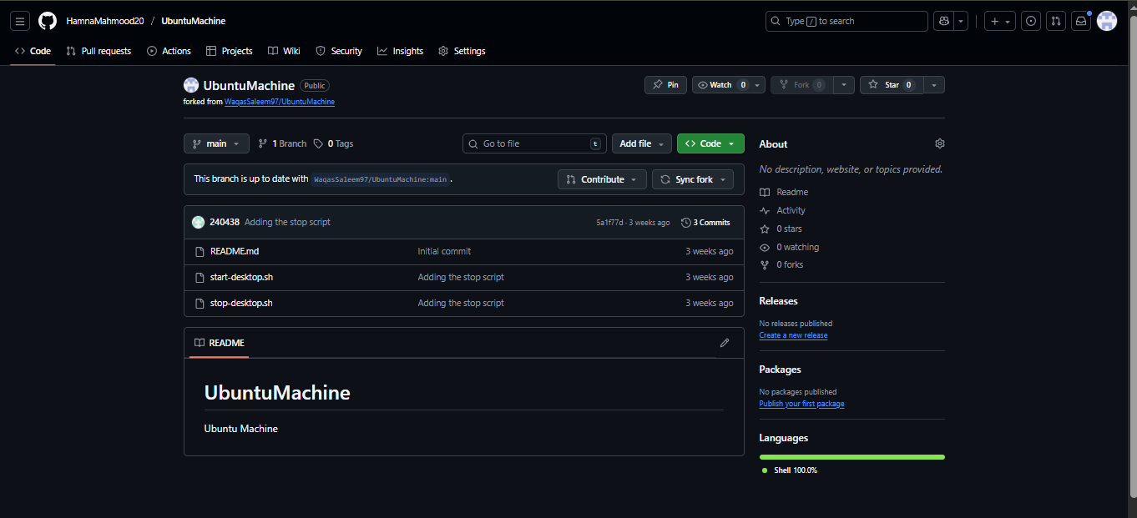
- Open a Codespace on your fork
  - Click Code → Open with Codespaces → Create codespace.
  - Wait for Codespace initialization.
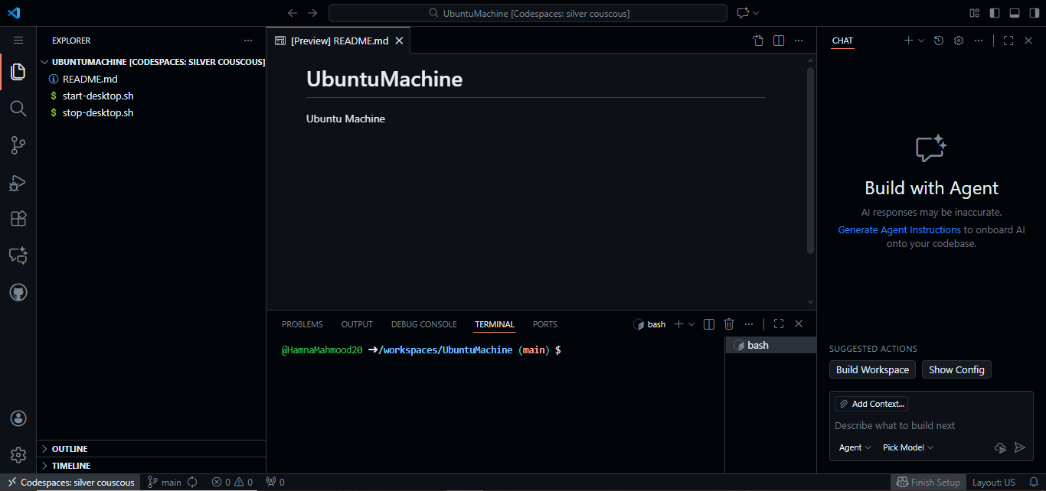
- Verify start/stop scripts exist and are executable
ls -l start-desktop.sh stop-desktop.sh
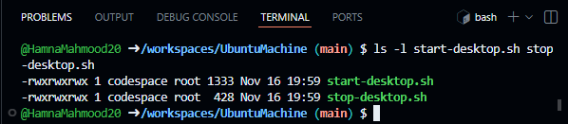
- Run the start script to launch the GUI
./start-desktop.sh
  - Capture terminal output showing successful start.
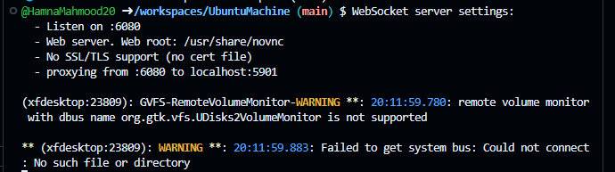
- Verify forwarded ports in Codespaces (Ports view)
  - Open Ports panel and confirm port 6080 is forwarded.
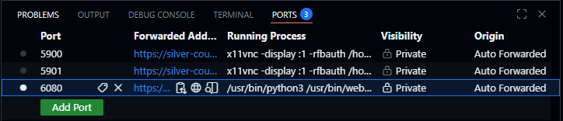
- Connect to the VNC HTML page
  - Open the forwarded port 6080 in the browser or Codespaces preview.

  - Click vnc.html.
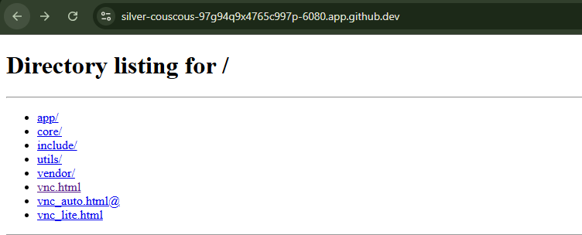
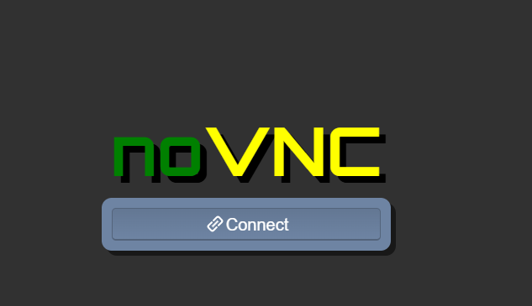
  - Enter password: codespace (do not show typed password).
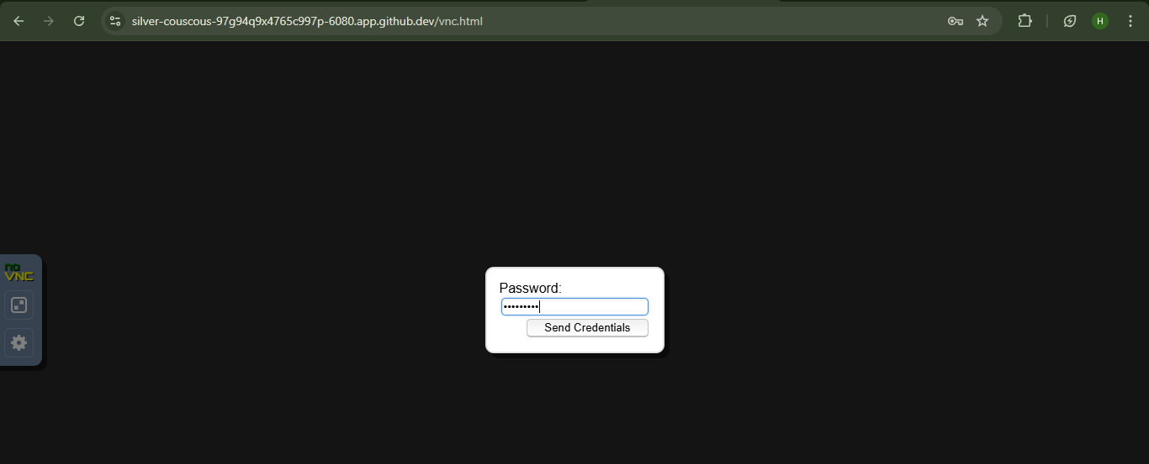
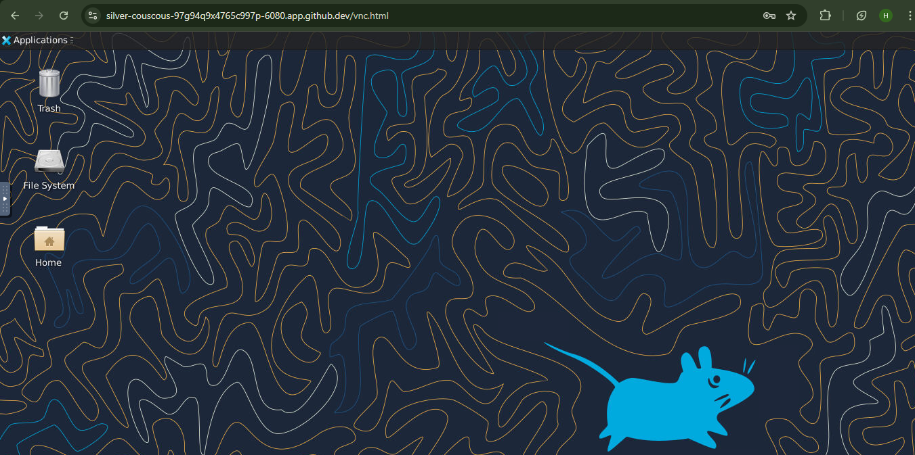
- Stop the GUI
./stop-desktop.sh
  - Capture terminal output showing GUI stop/cleanup.
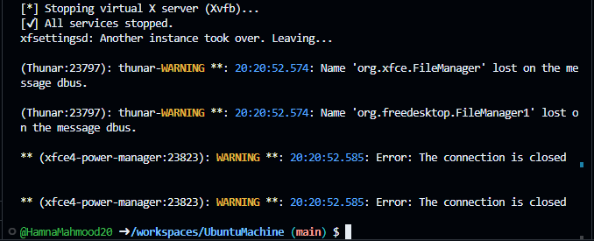

Exam Evaluation Questions

Group Management and Membership
Scenario: Create groups and manage a user’s primary and supplementary group memberships.
- Create groups g1, g2, and g3
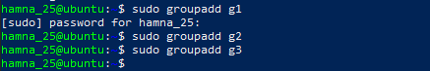
- Change examuser’s primary group and add supplementary groups
  - Primary: g3
  - Supplementary: g1, g2
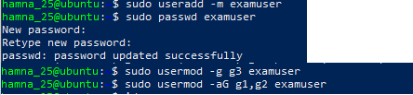
- Verify group changes
  - Show id examuser and relevant /etc/group lines
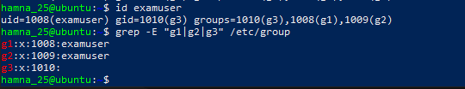

- Ownership and Permission Tasks
Scenario: Demonstrate ownership changes and apply symbolic and numeric permission changes.
- Create file and change ownership
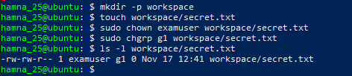
- Remove group/other permissions
  - Symbolic: chmod go-rwx workspace/secret.txt
  - Numeric: chmod 700 workspace/secret.txt
- Show final permissions

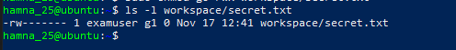

3. Pipes, Grep, and Redirection Practice
Scenario: Filter system logs and save results using redirection and piping.
- Grep for “error” or “fail” and show first 20 lines
grep -E 'error|fail' /var/log/syslog | head -n 20
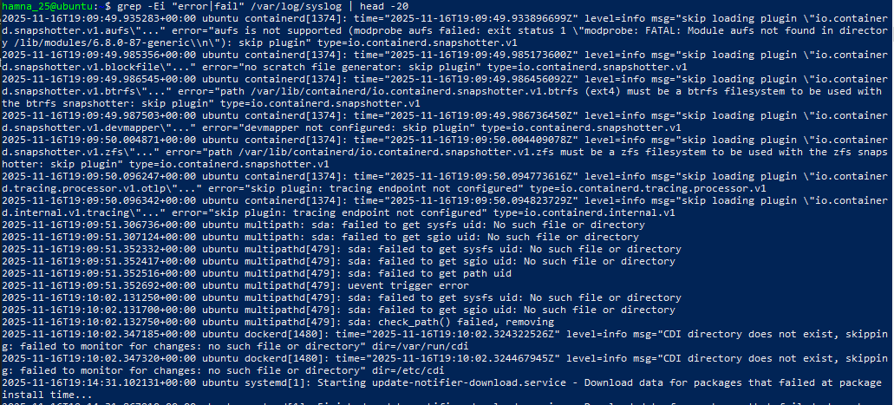
- Save filtered results to a file
grep -E 'error|fail' /var/log/syslog > ~/logs/errors.txt
grep -E 'warning|fail' /var/log/syslog >> ~/logs/errors.txt
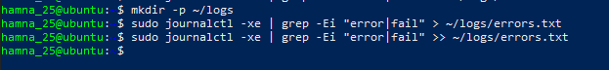
- View the saved file using a pager
less ~/logs/errors.txt
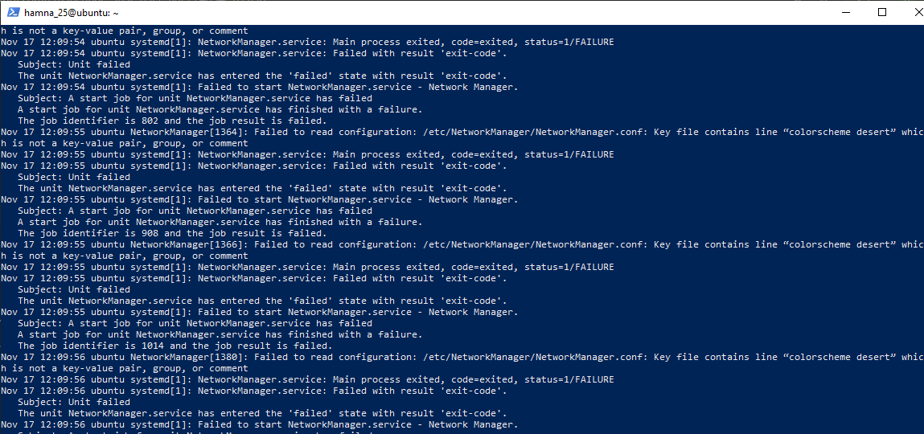

4. Script: Variables, Command Substitution, File & Dir Checks
Scenario: Build and run a script incrementally demonstrating variables, command substitution, and filesystem checks.
- Create setup.sh with shebang and variable var1
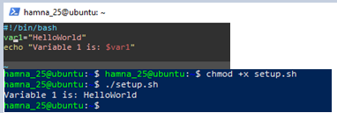

- Append command substitution storing ls -l output
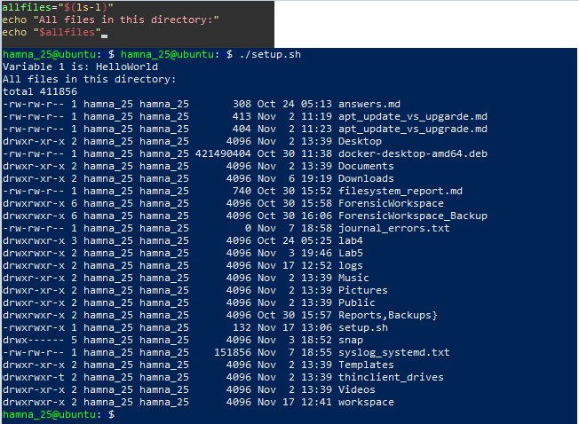

- Append directory/file checks for dir1 and dir1/file2
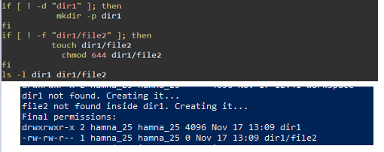

5. Script: Comparisons and String Tests
Scenario: Incrementally add numeric and string comparison tests and show both true/false cases.
- Overwrite setup.sh to set num=$1 and str=$2; add -eq test
Q5_eq_examples

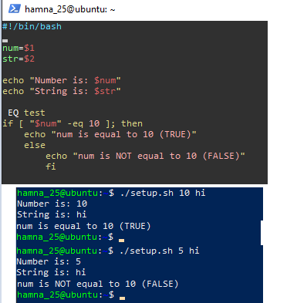
- Append numeric tests: -ne, -gt, -lt, -ge, -l
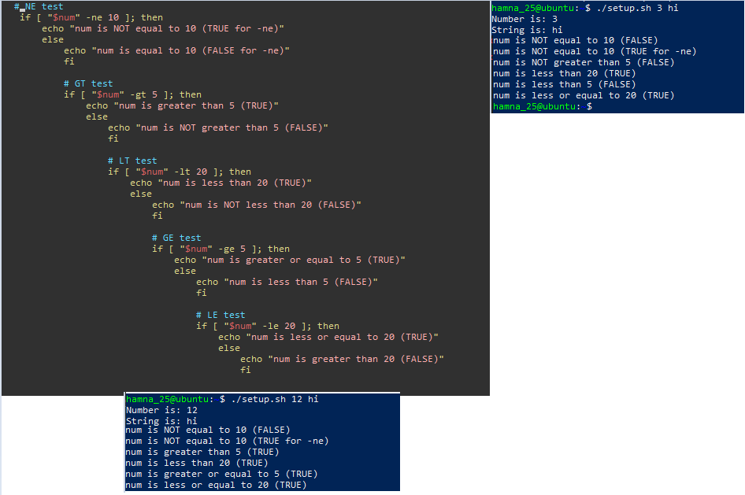

- Append string tests: equality (=), inequality (!=), zero-length (-z)
📸 Q5_string_tests.png
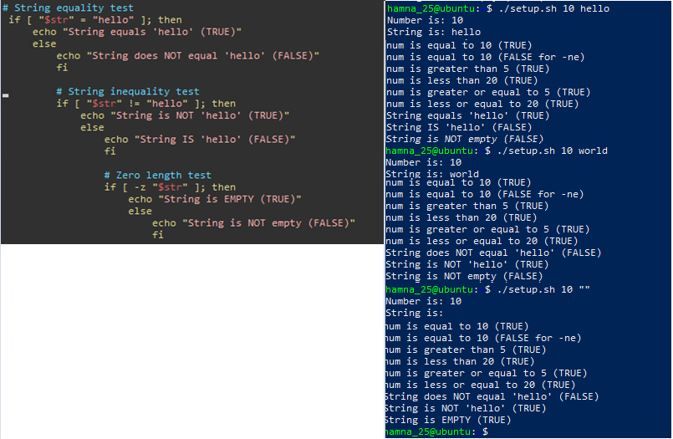

6. Script: For Loop and Argument Handling
Scenario: Print all provided arguments and demonstrate correct handling of quoted multi-word arguments.
- Create/overwrite setup.sh and print each argument using a for loop
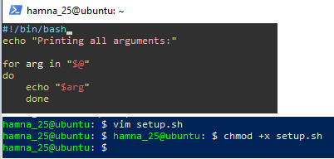
📸 Q6_script_forloop_vim.png
- Run script with single and quoted multi-word arguments
📸 Q6_forloop_run.png
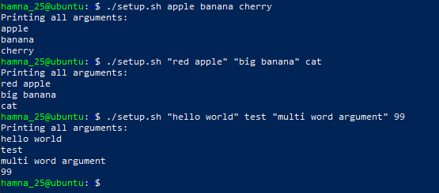

7. Script: While Loop Summation and Functions
Scenario: Implement an interactive summation function and a function returning a numeric result.
Interactive while-loop that accumulates numbers until q
📸 Q7_while_session.png
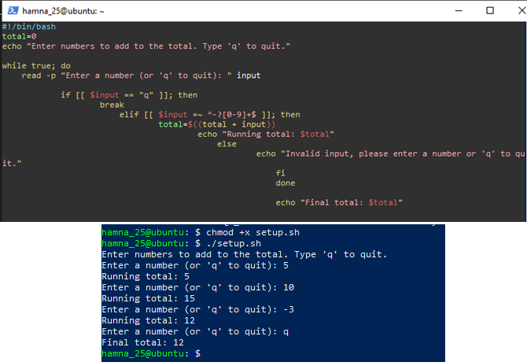

Function that sums two numeric arguments and demonstrates capturing the result
